Project Design Phase-II
Technology Stack (Architecture & Stack)

Date | 08 August 2026
Name | Shilpa Pachumbre
Project Name | House Rent MERN
Maximum Marks | 4 Marks

Here is the complete Technical Architecture customized specifically for your House Rent MERN, following your exact layout, diagram structure, and parameter tables:
Technical Architecture: House Rent MERN

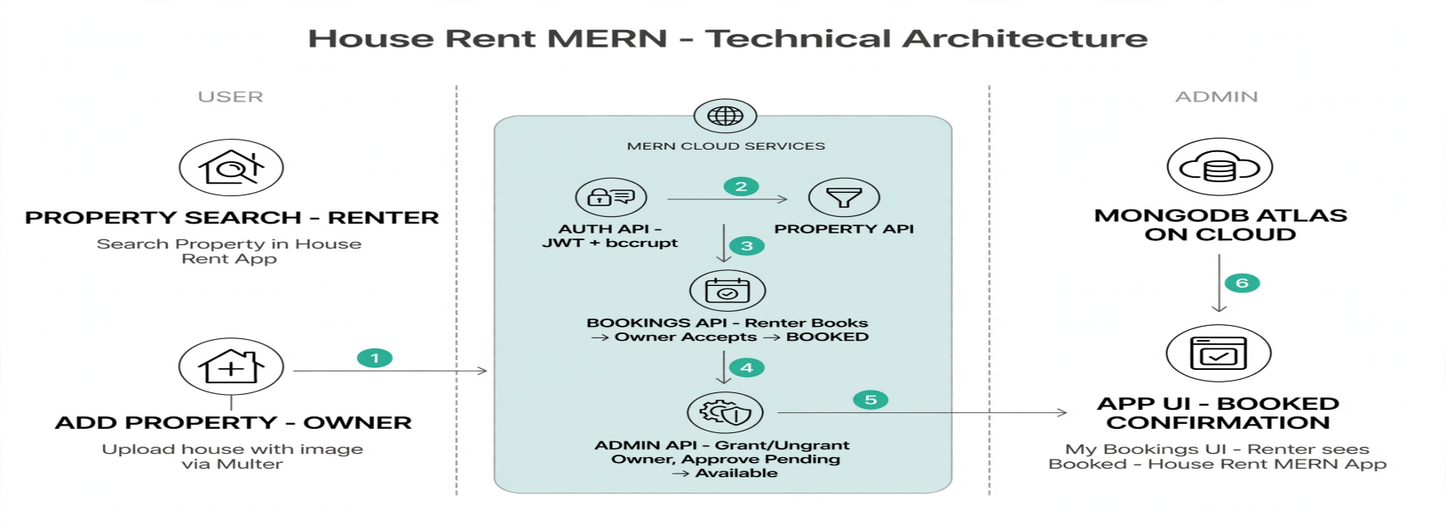

Table-1 : Components & Technologies:
S.No | Component | Description | Technology
 | User Interface | Renter Search & Book, Owner Add Property, Admin Panel | React.js, Node.js, Express.js, MongoDB, Tailwind CSS
 | Application Logic-1 | Login/Register Renter/Owner/Admin | Node.js, Express, JWT, bcrypt
 | Application Logic-2 | Renter Books -> Owner Accepts -> BOOKED | Node.js, Express - /api/bookings/accept
 | Application Logic-3 | Approve Pending->Available, Grant/Ungrant Owner | Node.js, Express - /api/admin/grant
 | Database | 3 Collections | MongoDB - Property Listings, Bookings, Users
 | Cloud Database | Cloud DB | MongoDB Atlas
 | File Storage | Property images | Multer Local + Cloudinary Cloud
 | External API-1 | Image Upload CDN | Cloudinary API
 | External API-2 | Location Map | Google Maps API
 | Notification Service | BOOKED confirmation | NodeMailer / Toast
 | Infrastructure (Server / Cloud) | Application Deployment on Local System / Cloud  Local Server Configuration:  Cloud Server Configuration : | Local:5173 Port 5000, Cloud: Render+Atlas

Table-2: Application Characteristics:
S.No | Characteristics | Description | Technology
 | Open-Source Frameworks | Modern open-source stack providing fast page rendering, scalable RESTful API design, and flexible document schema. | React, Node, Express, MongoDB, Mongoose
 | Security Implementations | Auth | JWT, bcrypt, Role-Based, CORS
 | Scalable Architecture | Justify the scalability of architecture (3 – tier, Micro-services) | React -> Express -> Atlas
 | Availability | 24x7 Uptime | Render + Atlas
 | Performance | Fast Search <2sec | Indexing, Multer compression, CDN

